**ORGANIC CHEMISTRY HOMEWORK PACKET**

**Chapter 22 Basics of Hydrocarbons**

**Textbook page771**

**11.** 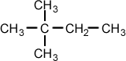

**12. a. propane b._2,3-dimethylpentane**

**Textbook page 773**

**16. Saturated hydrocarbons have the maximum number of hydrogen atoms per carbon. Unsaturated hydrocarbons have fewer hydrogen atoms per carbon.**

**Textbook page 790-793**

**45. b. 2,3-dimethylbutane**

**46. b. trans-2-pentene**

**47. a. unsaturated, because there is a double carbon-carbon bond**

**b. saturated, because the compound contains the maximum number of hydrogens per carbon atom**

**61 d.** 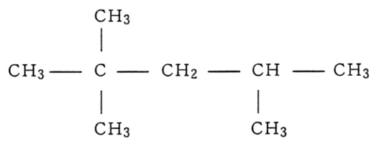

**61 a.**



**65. 2C8H18 (l) + 25O2 (g) 🡪 16CO2 (g) + 18H2O (l)**

**Textbook page 790-793**

**69a. 3 69e. 2**

**79. Alkanes contain only single bonds. Alkenes contain at least one double bond. Aromatic hydrocarbons contain a benzene ring or a similar ring. Cycloalkanes contain aliphatic chains that are arranged in a ring.**

**Textbook page 795**

1. **C 9. D 11. B 12. A 13. D 1 4. B, D**

**General Organic Chemistry**

1. What is the structural difference between an aliphatic and aromatic hydrocarbon?

Aliphatic – open chain hydrocarbon  
Aromatic- closed chained hyrdrocarbon (Benzene)

2. What is a homologous series of hydrocarbons?

Groups of hydrocarbons with similar bonding and follow the same general formula

3. What makes carbon able to form so many different compounds?

Carbons has 4 bonds sites, carbon can bond to other carbons and other atoms and long chains create many possibilities

4. What are structural isomers?

Compounds with the same molecular formula but different structural formulas

5. What is the smallest alkane that has a structural isomer? butane

6. Draw the structural formulas and state the names for the three isomers of pentane. Complete the chart.

|  |  |  |
| --- | --- | --- |
|  | STRUCTURAL FORMULA | NAME |
| ISOMER 1 |  | n-pentane (n=normal) |
| ISOMER 2 |  | 2- methyl butane |
| ISOMER 3 |  | 2,2dimethyl propane |

**Chapter 23 Functional Groups**

**Textbook page 802**

**3. They are used to introduce new functional groups to organic compounds**

**4a. OH, hydroxyl group; alcohol**

**4b. NH2 , amino group, amine**

**4c. COOH, carboxyl group; carboxylic acid**

**4d. Br , Halogen; halocarbon**

**4e. C-O-C, ether group, ether**

**4f. I, halogen; halocarbon**

**Textbook page 811**

**10. to introduce new functional groups to organic molecules and to convert alkenes to alkanes**

**14d.**

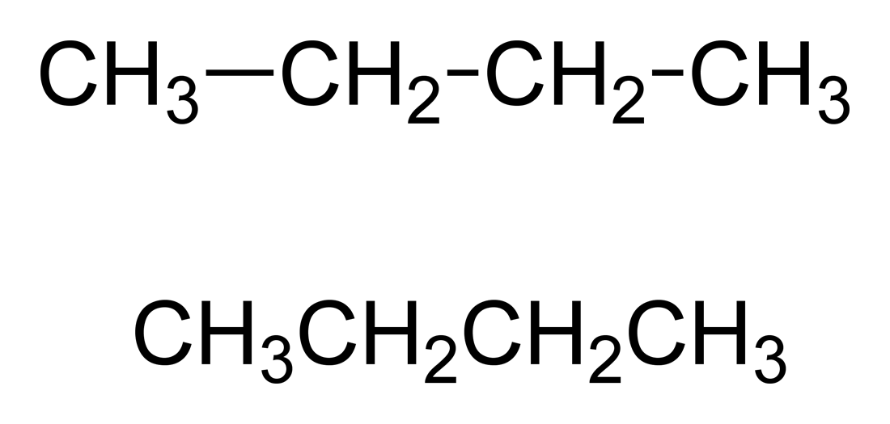

**14b.**

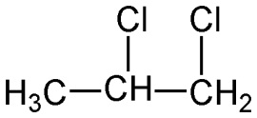

**Textbook page 820**

**21a. propanal 21b. 3-hexanone 21c. pentanoic acid**

**22a. CH3CH2CH2CH2CH2COOH 22b. CH3CH2CH2CHO 22c. CH3COCH2CH2CH3**

**Textbook page 827**

**24. They form when unsaturated monomers react and link to one another.**

**25. They form by the joining of monomers, usually with the loss of water**

**Textbook page 830-831**

**37. c. 2-methyl-2-propanediol**

**52 a.**

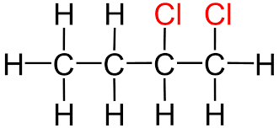

**52 b .**



**53 a. carboxy group, ethanoic acid (acetic acid) b. ether, diethyl ether (ethyl ether)**

**c. ketone (carbonyl group), propanone (acetone) d. alcohol (hydroxyl group), ethanol (ethyl alcohol)**

**C. ORGANIC REACTIONS**

1. Write the chemical formulas in place of the names in the equations below.

A. **esterification**: ethanoic acid + 1-propanol → propyl ethanoate + water

CH3COOH + C3H7OH 🡪 CH3COOC3H7 +H2O

B. **fermentation**: glucose → ethanol + carbon dioxide

C6H12O6 🡪 C2H5OH +CO2

C. **oxidation**: ethane + oxygen → water + carbon dioxide

C2H6 +O2 🡪 H2O +CO2

D. **substitution:** : ethane + bromine → bromoethane + hydrogen bromide

C2H6 +Br2 🡪 C2H5Br + HBr

E. **addition:** ethene + bromine → 1,2 dibromoethane

C2H4 + Br2 🡪 C2H4Br2

2. Complete each of the following chemical equations.

A. C6H14 + O2 → CO2 + H2O (combustion)

B. C3H6 + Cl2 → C3H6CL2 (addition)

C. C3H8 + Cl2 → C3H7Cl + HCl (substitution)

3. Polyethylene is a tough, flexible plastic used to make bottles, garbage bags and many other household items. Teflon is an inert, tough and nonflammable material used for electrical insulation and nonstick coatings for cooking utensils. Draw the structural formulas and state the names for the monomers that will become these useful polymers. (Hint: Find the answers in your textbook & notes)

Polyethylene Teflon

